**Assignment 1**

**Program 1**

**Problem Definition:**

Write a Python program to check the validity of a password chosen by a user. To be considered valid, a password must

1. contain at least 1 letter between [A-Z],
2. contain at least 1 letter between [a-z],
3. contain at least 1 number between [0-9],
4. contain at least 1 special character from [$#@],
5. have a minimum length of 6 characters, and f) have a maximum length of 12 characters.

Your program will consist of two user-defined functions: validate() and main(). The validate() function implements the validation procedure described above. The parameter (or input) to the function is a string s. If s fits the above criteria, print valid Otherwise, print not valid. Also implement logging.

**Code: password.py**

import re

import logging

logging.basicConfig(filename='pass.log',format='%(asctime)s %(message)s',level=logging.DEBUG) #storing the log records in a log file

def validate(s):

flag=0

if (len(s)<6 or len(s)>12): #checking the password length

logging.error("Password length should be between 6 to 12")

flag=1

if(re.search('[A-Z]',s) is None): #checking for uppercase letter

logging.error("Password should have atleast one uppercase letter")

flag=1

if(re.search('[a-z]',s) is None): #checking for lowercase letter

logging.error("Password should have atleast one lowercase letter")

flag=1

if(re.search('[0-9]',s) is None):

logging.error("Password should have atleast one number")

flag=1

if(re.search('[@$#]',s) is None): #checking for special character

logging.error("Password should have atleast one special character from $@#")

flag=1

if(flag==0): #checking if all the required conditions are satisfied

print("Valid password")

else:

print("Invalid password")

def main():

s=input("Enter the password: ") #accepting the input

logging.info('Reading the password')

validate(s)

if __name__ == "__main__":

main()

**Screenshot of output:**

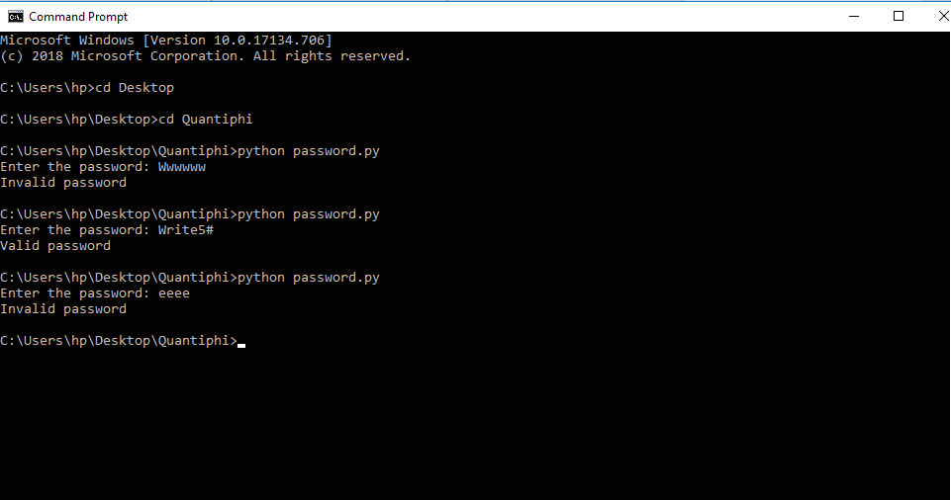

**Log File: pass.log**

2019-05-09 22:06:18,837 Reading the password

2019-05-09 22:06:18,852 Password should have atleast one number

2019-05-09 22:06:18,852 Password should have atleast one special character from $@#

2019-05-09 22:07:03,308 Reading the password

2019-05-09 22:07:11,124 Reading the password

2019-05-09 22:07:11,124 Password length should be between 6 to 12

2019-05-09 22:07:11,124 Password should have atleast one uppercase letter

2019-05-09 22:07:11,124 Password should have atleast one number

2019-05-09 22:07:11,124 Password should have atleast one special character from $@#

**Program 2**

**Problem Definition:**

Write a program to find frequency of each distinct word in a given text file ‘input.txt’. Your Output should be stored in a different file named‘output.txt’ in alphanumeric order. Each line should contain the word and its frequency separated by a comma. (if numeric values are present in file they should be at the start of output file). You can take any text file as your input file.

**Code: frequency.py**

def freq(text):

str1=text.split() #split the text by space in list str1

str2=[] #declare empty list str2

for i in str1:

if i not in str2: #put unique words in str2

str2.append(i)

str2.sort() #sort the list str2

output = open("output.txt","w")

for i in range(0, len(str2)):

output.write(str2[i]) #write each unique word to file

output.write(',') #seperate words and count by ,

count=str1.count(str2[i]) #count the frequancy of words

count = str(count)

output.write(count)

output.write('\n') #each unique word on new line

output.close() #close the file

def main():

input = open("input.txt","r") #Read the input from file 'input.txt'

text = input.read() #read the lines of input file

input.close() #close the file

freq(text) #call the freq() and pass text as parameter

if __name__ == "__main__":

main()

**input.txt**

The fort walls were dismantled in 1864 and massive building works transformed the city in grand colonial style . When Bombay took over as the principal supplier of cotton to Britain during the American Civil War , the population soared and trade boomed as money flooded into the city .

**output.txt**

,,1

.,2

1864,1

American,1

Bombay,1

Britain,1

Civil,1

The,1

War,1

When,1

and,2

as,2

boomed,1

building,1

city,2

colonial,1

cotton,1

dismantled,1

during,1

flooded,1

fort,1

grand,1

in,2

into,1

massive,1

money,1

of,1

over,1

population,1

principal,1

soared,1

style,1

supplier,1

the,5

to,1

took,1

trade,1

transformed,1

walls,1

were,1

works,1